**Across the aisle, ‘defund the police’ is blamed for crime increases. The problem: in most cities, it never happened.**

The “defund the police” movement started to gain traction after the murder of George Floyd in 2020. While some believe the movement to be calling for a complete dismantling of law enforcement, others characterize it as pushing for reallocating funds away from law enforcement agencies to other community and mental health organizations.

But regardless of how it’s defined, politicians and pundits are blaming an increase in crime on the defund movement.

During his State of the Union Address on March 1, 2022, President Biden declared:

“We should all agree: the answer is not to defund the police—it's to fund the police. Fund them!”

Los Angeles County Sheriff Alex Villanueva [held a press conference on March 9](https://lasd.org/defunding-has-consequences/) about staff shortages and crime, opening with and titling his presentation: “defunding has consequences.”

La'Ron Singletary, a Rochester, NY former police chief who is now a candidate for Congress, said on [Fox News earlier](https://video.foxnews.com/v/6305059291001#sp=show-clips) this year he is “seeing the consequences of the defund the police movement.”

Dallas Police Chief Eddie Garcia said in a [TV interview with Jeanine Pirro](https://twitter.com/JudgeJeanine/status/1408959206946922496?s=20) that the reason for violent crime increases are, in part, due to the “dismantling [and] defunding combination, you have officer morale — where honorable, respectable officers have felt under siege, unappreciated, undervalued — they’re human, and that impacts their work productivity. What’s happened is we’ve lost proactive police engagement where we need it the most.”

With this narrative growing across the political spectrum, we gathered data to answer some questions about how much, if at all, law enforcement agencies were defunded since the movement began.

**Q: Have law enforcement agencies lost money in the last four fiscal years?**

**A: Largely, no.**

According to an ABC Owned Television Stations analysis of more than 100 city and county budgets across the country, about 90% of local governments we studied allotted more funding to law enforcement agencies in fiscal year 2022 than they did three years before in fiscal year 2019.

* 8* agencies saw decreases larger than 2% between 2019-2022.
  + Seattle Police Department in Washington – by 11%
  + Chula Vista Police Department in California – by 10%
  + Buffalo Police Department in New York – by 8%
  + Washington D.C. Metropolitan Police – by 7%
  + Milwaukee Police Department in Wisconsin – by 6%
  + Corpus Cristi Police Department in Texas – by 5%
  + New York City Police Department – by 3%
  + St. Louis Police Department in Missouri – by 2.3%

*(*9 if you include Evanston Police Department, which saw a decrease of 41%. Some of this was due to pension funds moving into a non-departmental section, but it doesn’t explain the totality of the drop. Waiting on clarification from the city of Evanston.)*

* 10 saw relatively flat budgets, meaning they were up or down less than 2% between 2019-2022.
  + Boston Police Department in Massachusetts – down by 1%.
  + Glendale Police Department in Arizona – down by 1%
  + Suffolk County Sheriff in New York – down by one thousandth of a percent.
  + Rochester Police Department in New York – up by 0.2%
  + Richmond Police Department in Virginia – up by 0.4%
  + Chandler Police Department in Arizona – up by 1%
  + Newark Police Department in New Jersey – up by 1%
  + Portland Police Department in Oregon – up by 1%
  + Honolulu Police Department in Hawaii – up by 1.5%
  + Wilmington Police Department in Delaware – up by 1.7%
* 42 agencies saw budget increases of at least 2%, but less than 10% between 2019-2022.
* 49 agencies saw budget increases of at least 10% between 2019-2022.

*

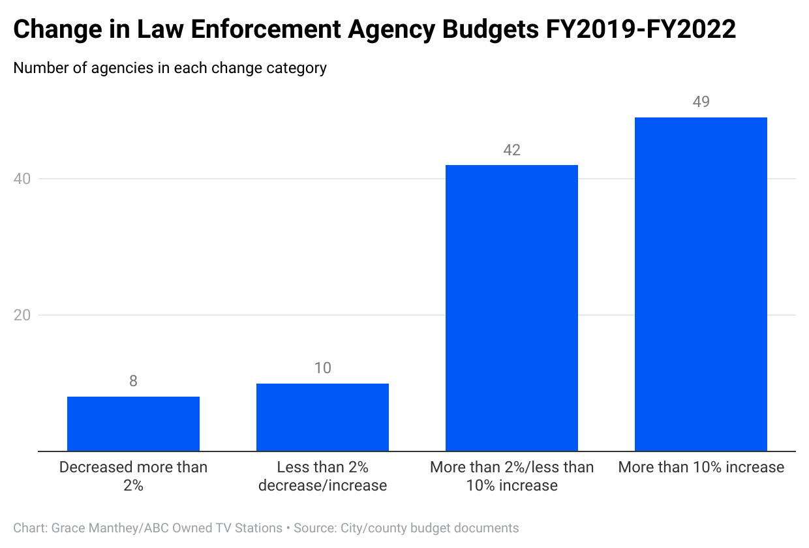

Of the top 10 increases in adopted budgets between FY19 and FY22, five were in California: Sacramento PD (+44%), Bakersfield PD (+42%), Orange County Sheriff’s Department (+28%) Riverside County Sheriff (+26%), and San Diego PD (+26%).

* Oakland PD and San Jose PD saw 18% increases
* Chicago PD and San Bernardino County Sheriff saw 15% increases
* Fresno PD saw a 14% increase
* Raleigh PD had an 11% increase
* Los Angeles PD and Houston PD saw 9%
* Los Angeles County Sheriff saw a 8% increase
* San Francisco PD saw a 4% increases.
* Philadelphia PD saw a 3% increase in its proposed budget.

**Q: Have law enforcement budgets also kept up with total spending?**

**A: A majority of departments saw percentage point decreases in the share their departments took up of total budgets – But most saw only small changes**

While the majority of law enforcement agencies had increases in the dollar amount they were getting from their local governments, roughly two-thirds saw decreases in law enforcement budgets as a percentage of total budgets comparing FY19 to FY22.

In other words, for many police departments, funding is taking up a slightly smaller share of the overall city budgets in FY22 than they did in FY19.

But those changes are extremely small. Only a third of agencies saw a drop of more than a percentage point in their share of the overall budget and just 14* agencies saw a decrease of more than two percentage points**.**

*(*15 if you include Evanston Police Department)*

Year-to-year changes averaged at most about two percentage points, increasing or decreasing.

In all but three of those 14 departments that saw at least a two percentage point decrease in the share of the total spending going towards their own law enforcement agencies, overall funding for the department increased – making it hard to argue they were actually “defunded.”

Some examples:

* Oakland Police Department:
  + Percentage of the total budget decreased from about 19% in FY19 to 16.5% in FY22.
  + 18% increase dollar amount budget between FY19 and FY22.
* Chicago Police Department:
  + Percentage of the total budget decreased from about 14.5% in FY19 to 10.5% in FY22.
  + 15% increase dollar amount budget between FY19 and FY22.
* New Orleans Police Department:
  + Percentage of the total budget decreased from about 17% in FY19 to 15% in FY22.
  + 13% increase dollar amount budget between FY19 and FY22.
* Santa Ana Police Department:
  + Percentage of the total budget decreased from about 22% in FY19 to 18% in FY22.
  + 7% increase dollar amount budget between FY19 and FY22.

The Chula Vista Police Department saw both a 10% decrease in the budgeted dollar amount between FY19 and FY22 and a decrease in the share of the total budget from 16% in FY19 to 11% FY22. But the biggest reason for the large decrease was not due to a push to defund the department, but a reallocation of the “unfunded accrued liability expense for retirement benefits” from a personnel expense included in the police departments budget to a transfer out expense not included in the department’s budget.

*Note: These shares may not be comparable across cities/departments because of the different ways cities define “total budgets” in their documents.*

**Q: Even if there weren’t huge changes between FY19 and FY22, did cities defund law enforcement in response to the ‘defund the police’ movement and then reverse it?**

**A: A handful of departments saw a decrease in FY21 after the murder of George Floyd and then an increase in FY22. But for many local governments, the reason wasn’t necessarily social justice.**

20 departments saw decreases of at least 2% between these FY20 and FY21, but only three of those departments kept the trend and saw decreased budgets by at least 2% the next year. The remaining 17 departments had budgets that either stayed the same or went back up the next year, for FY22.

* 20 agencies saw decreases larger than 2% between 2020-2021.
* 47 saw relatively flat budgets, meaning they were up or down less than 2% between 2020-2021.
* 37 saw budget increases of at least 2%, but less than 10% between 2020-2021.
* 5 saw budgets increases by at least 10% between 2020-2021.

*(*48 if you include Evanston Police Department)*

**Austin Police Department**

One example of an actual response to the “defund the police” movement is the [Austin Police Department](https://financeonline.austintexas.gov/afo/afo_content.cfm?s=1), which saw a 33% drop in its adopted budget, from $434 million in FY20 to $293 million in [FY 21](https://assets.austintexas.gov/budget/20-21/downloads/2020-21_Approved_Budget.pdf). (Although the [next year’s budget (FY22)](https://assets.austintexas.gov/budget/21-22/downloads/FY22_Approved_Budget.pdf) showed the amended amount to be about $310 million.)

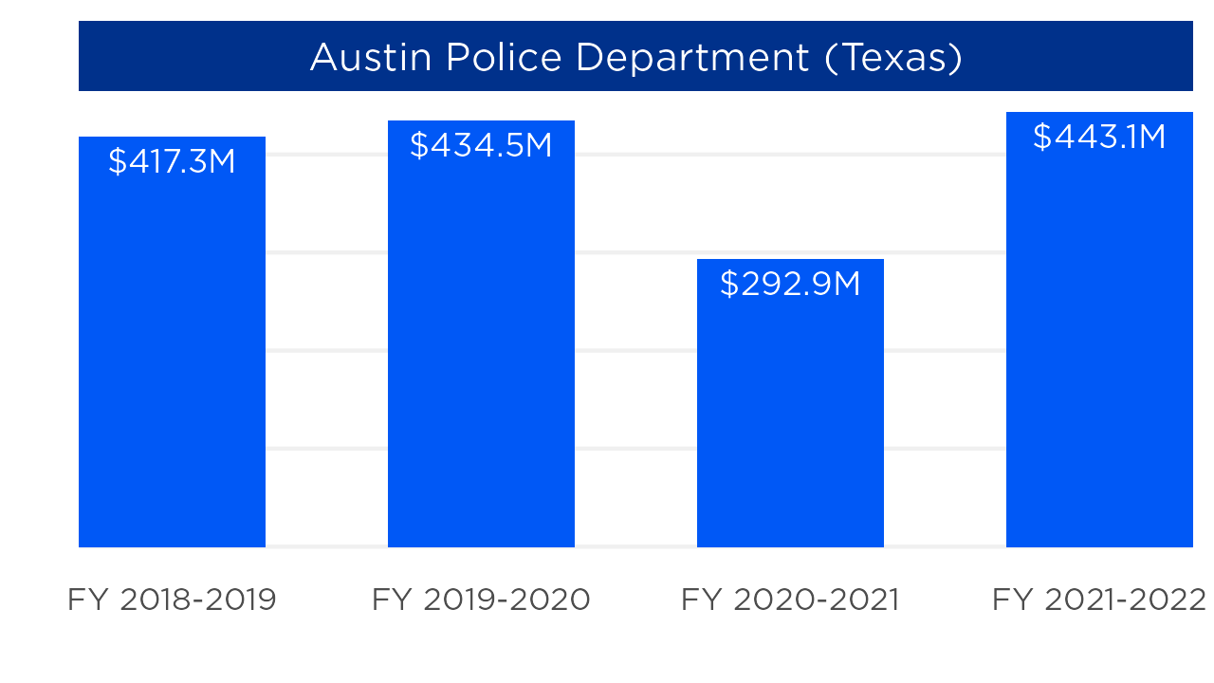

The plan was to reallocate funding to other community safety needs including:

* Additional staffing and resources for the Office of Police Oversight and the Equity Office
* Full implementation of recommendations for a clinician‐based approach to mental health emergency response including an expanded EMCOT contract and 7 new community health paramedics
* Expanded funding for mental health, family violence prevention, and immigrant legal services in the Austin Public Health department
* More funding for the Housing Trust Fund
* Additional police officer training on trauma‐informed response, unconscious bias, racial and cultural sensitivity, and on the use of Noloxone for people experiencing a drug overdose
* The creation of a new Civil Rights Office housed within the Law Department.

Then, in FY22, the department saw a 51% increase to about $443 million, so the city would be in compliance with the Texas Legislature’s HB 1900, which “prohibits a municipality with a population above 250,000 from decreasing its Police budget amount year-over-year, effective for the adoption of the FY 2021-22 budget,” according to the city budget.

So, did the city really get a chance to see if it was going to work?

**Minneapolis Police Department**

The city of Minneapolis – the city where George Floyd was murdered – had a similar, but less drastic change compared to Austin. In FY21, the police department’s adopted budget was about $164 million, a 15% decrease from the $193 million in FY20. In FY22, the budget went back up to $193 million.

***Total police funding for Minneapolis PD:***

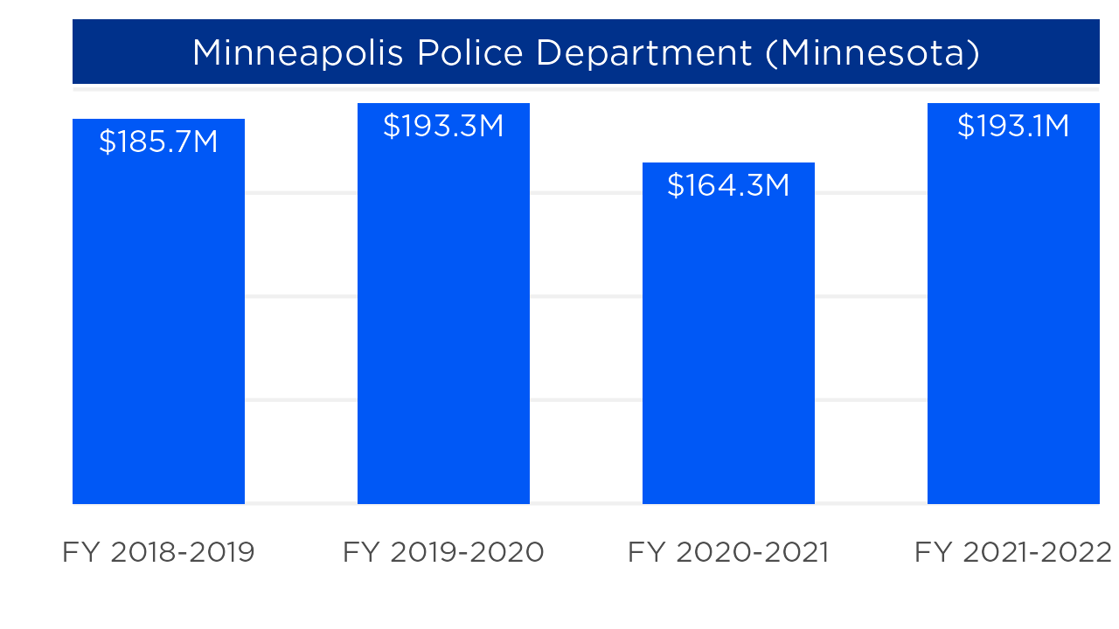

However, this wasn’t just limited to the police department. Minneapolis’s entire city budget decreased about 6% from 1.54 billion in FY20 to 1.45 billion in FY21. Then, it went back up 8% to 1.57 billion in FY22.

For FY19, the police department’s budget was about 11%. In FY20, it was about 13% of the total city budget. Then, in FY21 it went back to about 11%, and then back up to 12% in FY22. So, while some of the cuts may have been due to attempts to “defund” or reallocate funding, some of the change can also be attributed to the entire city budget decreasing.

***Percent of total city funds going to Minneapolis PD:***

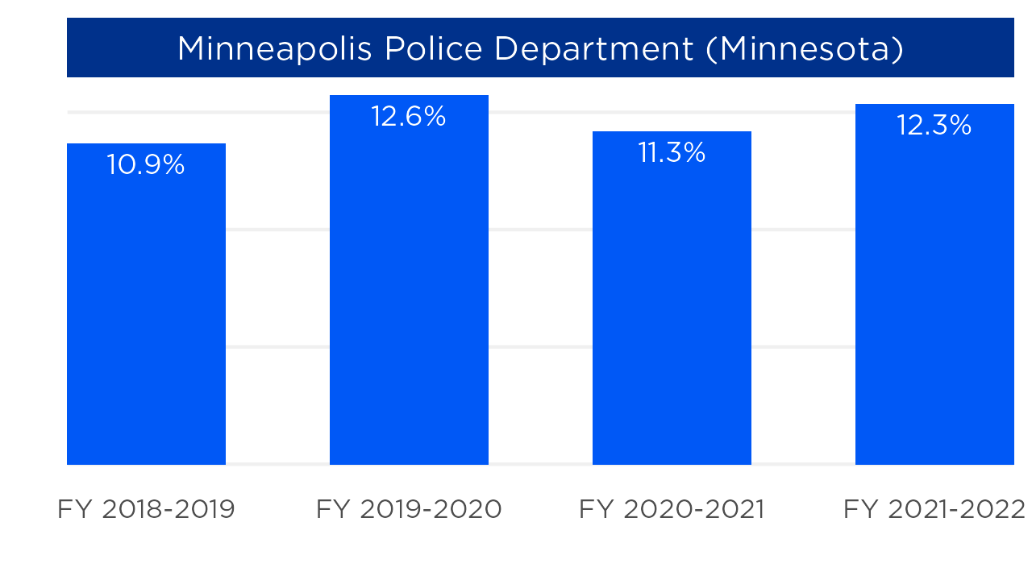

**Albuquerque Police Department**

In FY21, Albuquerque’s police department did take about a 12% decrease in funding from the year before, as well as taking up a smaller percentage of the total budget. However, the language in the budget did not suggest the reason was due to the “defund” movement.

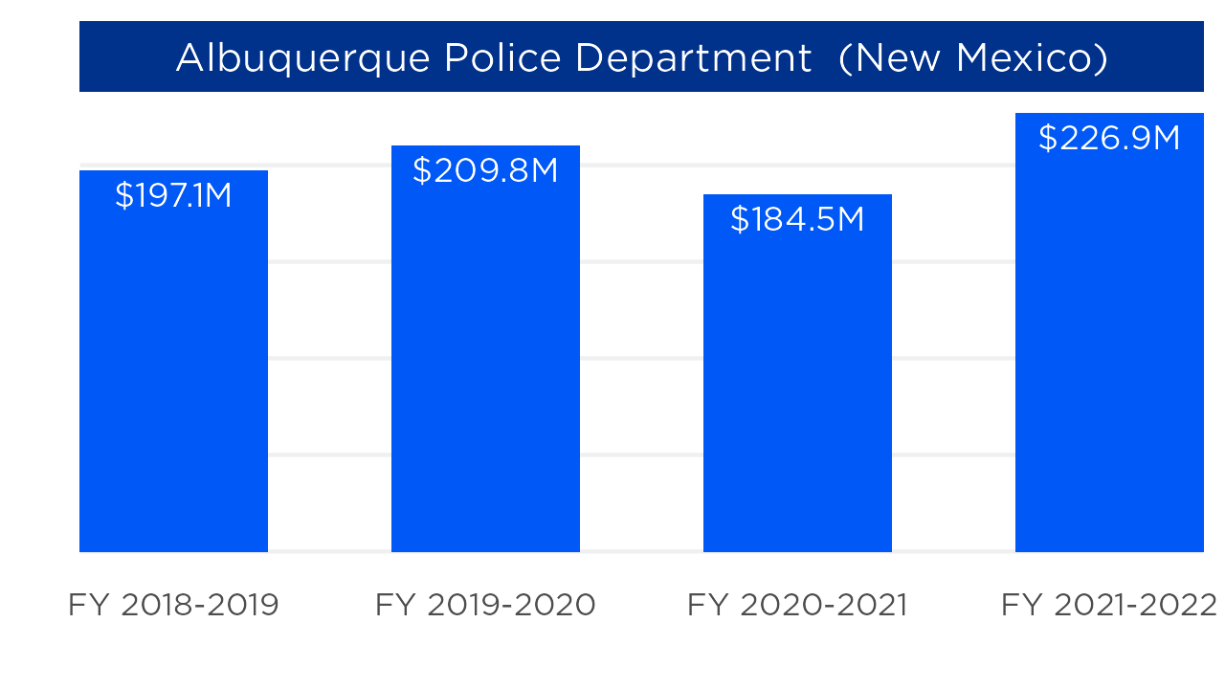

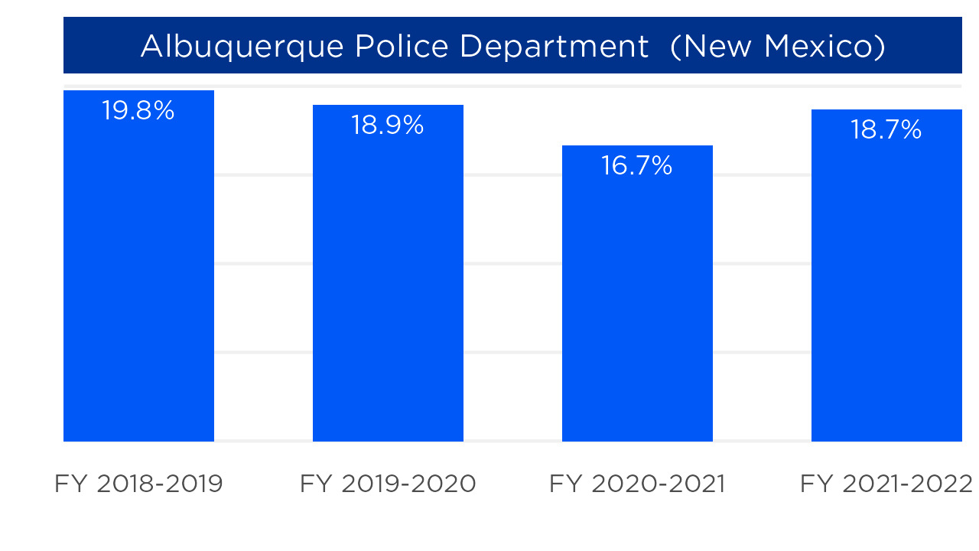

The FY21 budget acknowledged the protests of police violence, but shortly after said, “Our high levels of crime mean we need to continue to invest in police, including bringing the number of officers back to their historical levels. The Police Department has deployed millions of capital dollars to improve our decades old technology and investigative tools.”

The budget also established the Albuquerque Community Safety Department, which is a third public safety department responsible for responding to calls “not best served by the police.” The funding for the ACS department that year was about $2.5 million which doesn’t make up for the difference in funding from the previous year.

But it wasn’t just the police department that saw a decrease in funding, the fire department also saw a 33% decrease in funding that year compared to FY20.

**Other examples**

* **Louisville Police Department** had a large decrease in FY21 in its share of the total city budget (from 25% in FY20 to 21.5% in FY21), but it was because of an [increase in federal grants](https://louisvilleky.gov/government/management-budget/fy22-budget) to the total budget, not a decrease in funding to LPD. The department had a very slight increase in dollar amount funding.
* The **Lincoln Police Department** in Nebraska started including capital project transfers in its total budget in FY21, so the total budget increased, causing the percentage of the police department funds to decrease from 8% to 7%. Lincoln PD also had a slight increase in its dollar amount budget.

**Q: Why does it matter? If police are getting more funding, does that mean there will be fewer crimes?**

**A: Data shows more funding for police doesn’t necessarily mean fewer crimes.**

An ABC Owned Television Station analysis of [state and local police funding](https://fred.stlouisfed.org/series/G160851A027NBEA#0) and violent [crime data in the U.S.](https://crime-data-explorer.app.cloud.gov/pages/explorer/crime/crime-trend) overall between 1985 and 2020 found no relationship between year-to-year police funding and year-to-year crime rates. (An [analysis by the Washington Post](https://www.washingtonpost.com/politics/2020/06/07/over-past-60-years-more-spending-police-hasnt-necessarily-meant-less-crime/) found similar results using data from 1960 to 2018.)

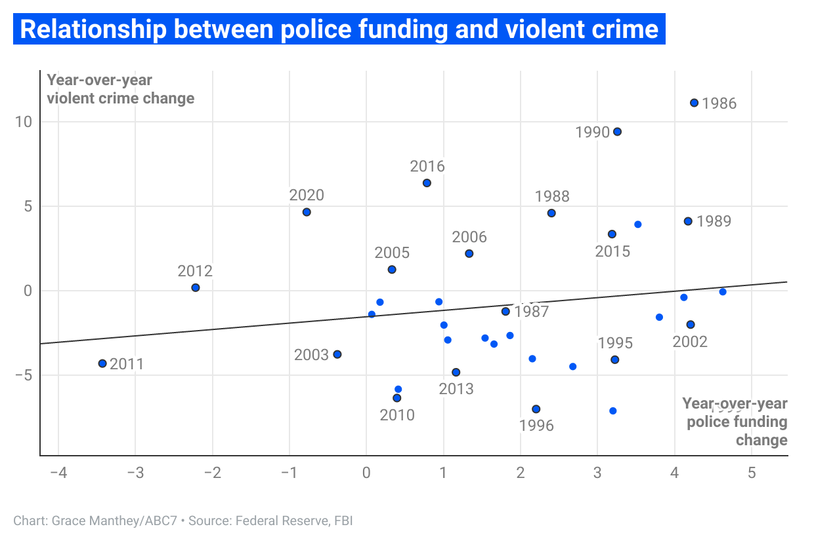

In 2011 and 2012, for example, nationwide funding for state and local police decreased by 3.4% and 2.2%, respectively. But, violent crime decreased 4.3% in 2011 and stayed about the same in 2012.

However, violent crime did increase by about 3% in 2015 and 6% in 2016. So, what if there is a delay in the impact funding has on crime? Afterall, crime started to decline in the 90s, after years of police spending increasing. But even comparing violent crime changes to the police funding changes four years before, no relationship emerges.

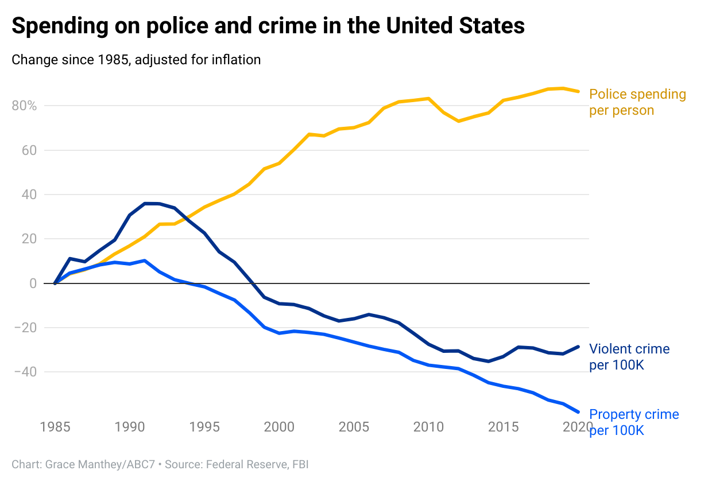

Add something here about clearance rates???

**Interactive graphic**

[This searchable interactive graph](https://abcotvdata.github.io/police-budgets/police-budgets-graphs/index.html) shows police department budgets for FY19 through FY22 and can be embedded in any story.

**Police Budget reporting guide**

First, do not hesitate to reach out to the data journalists with questions. We are happy to help.

This is a reporting guide to be used alongside the above budget analysis findings. You’ll have access to more than 100 police department budgets from 2019 to 2022. In some cases, we may be able to get you the next fiscal year (FY23) as this is budget season for many municipalities.

In the data there are two key sets of numbers to look at: “Actual” and “Budget/Approved/Adopted/etc.”

The “Actual” budget is what the agency ended up spending that year.

The other number (Budget/Approved/Adopted/etc.) is what the government planned on spending. Notice that the two numbers for the same year are different, one could be higher or lower, and that’s worth investigating.

* If higher: Was there more overtime? Were patrols increased and where?
* If lower: How did the city manage to cut costs? Is the city losing police? Did COVID budget woes have anything to do with it?

We’ve provided two sets of data: One comparing just the adopted budgets for each department (that is, the budget adopted by the local government for the year), and one showing the other available types (actual spending and, in some cases, revised or estimated budgets.)

Next, you’ll see the 2019 to 2022 change numbers, that’s a percent change in the planned budget from before the George Floyd murder and the “defund the police” discussion that ensued – up through the most recent budget. That will show how much the budget has changed.

We’ve also included the total budgets for the entire local government (that is all the departments of the city or county) to show whether police budget changes moved up or down consistently with the overall local government budget. We show the police budget as a percentage of the total budget.

Depending on the city, it may be defined as the city’s total “expenditures,” total “budget,” or total “uses.” Local governments include different things in this total number. Some include transfers, capital improvement programs, for example, others do not. We tried to be consistent as possible, but there are differences. ***For that reason, do not compare the percentages of total spending in one department to another. The comparison here is each individual department compared to itself.***

There is more than likely a hardball question to ask, you have the official numbers so, “What changed between 2019 and 2022?” For instance, New York City had numerous politicians and civil leaders, backing the “defund” movement. The result was a 3% drop in funding and a decrease of less than a percentage point in the share of the total budget.

Good questions to ask:

* Was that enough of a decrease?
* Have they changed priorities or shifted their stance?
* Where did that money go?

Since police agencies have not been defunded, it’s a good chance to also ask about what could help the crime increases – particularly gun violence – seen in many cities.

If more police and more police funding don’t necessarily stop crime, as the data above suggests over the long-term, then what solutions have some places tried in the past or now that seem to have helped reduce crime and gun violence?

For many departments, we have police staffing numbers by year. Feel free to reach out and we can help get those for you.

Staffing numbers can be a key element in these stories. For example, the NYPD is losing thousands of veteran police — a story on its own, unrelated to funding. In cities and counties where this is happening, it is worth asking local officials about.

Crime rates are rising across the board, so getting academics also can add depth and authority to the story.

***For instance, WABC used Maria Haberfeld in a story about police retirements, and may use her again for this story. While budget declines were minimal in NYC, some police officers, unions and other supporters say that the summer of protests spawned by the Floyd case and the related calls for defunding the police had a demoralizing effect on some officers.***

*Maria Haberfeld, a criminologist and professor at John Jay College of Criminal Justice, laid plenty of blame at the feat of New Yorkers.*

*"They basically feel like the profession is under attack," Haberfeld said. "They're under attack on a daily basis whether they do right or wrong, and who wants to go to work every day being disrespected and criticized.”*

***It would be good to talk to activists who had called for reducing or realigning police funding to get their perspective about the success or failure of those efforts, as well as their take on calling for reducing or realigning police funding amid rising crime – and particularly gun violence – in cities.***

***Crime survivors and victim families’ points of view can be helpful and powerful in these stories. In the few communities where police budgets did get cut, even temporarily, how do they feel about that?***